**PROGRAMMING IN JAVA**

**BCA-DS-402**

**Manav Rachna International Institute of Research and Studies School of Computer Applications**

**Department of Computer Applications**

| **Submitted By** | |
| --- | --- |
| **Student Name** | **Utkarsh Gautam** |
| **Roll No** | **23/SCA/BCA(DS&BDA)/027** |
| **Programme** | **Bachelor of Computer Applications** |
| **Semester** | **4th Semester** |
| **Section/Group** | **4 - E** |
| **Department** | **School of Computer Applications** |
| **Batch** | **2023-26** |
| **Submitted To** | |
| **Faculty Name** | **Dr. Priyanka Sharma** |



**SCHOOL OF COMPUTER APPLICATIONS**

**INDEX**

| S.No | Program | Signature |
| --- | --- | --- |
| 1 | Hello World Program |  |
| 2 | Sum of Two Numbers |  |
| 3 | Check Even or Odd |  |
| 4 | Sum and Average of 5 Numbers |  |
| 5 | Factorial of a number |  |
| 6 | Fibonacci Series |  |
| 7 | Reverse a Number |  |
| 8 | Check Palindrome (Number) |  |
| 9 | Simple Calculator |  |
| 10 | Check Prime Number |  |
| 11 | Check Armstrong Number |  |
| 12 | Largest of two numbers using ternary operator |  |
| 13 | Multiplication Table |  |
| 14 | Sum and Average of Array Elements |  |
| 15 | Reverse a String |  |
| 16 | Factorial using Recursion |  |
| 17 | Sort an Array |  |
| 18 | Check Palindrome (String) |  |
| 19 | Count Vowels and Consonants |  |
| 20 | Simple Banking System |  |
| 21 | Type Casting Demonstration |  |
| 22 | Generate Prime Numbers in a Range |  |
| 23 | Simple Class with Methods |  |
| 24 | Class with Parameterized Constructor |  |
| 25 | Find Area of Rectangle |  |
| 26 | Bank Account with Deposit & Withdraw Methods |  |
| 27 | Method Overloading |  |
| 28 | Static Methods Demonstration |  |
| 29 | Method Overriding |  |
| 30 | Getters and Setters |  |
| 31 | Class with Multiple Methods |  |
| 32 | Object Passing in Methods |  |
| 33 | Area & Perimeter using Super & This |  |
| 34 | Counting Objects using Static Members |  |
| 35 | Abstract Classes & Methods |  |
| 36 | Multilevel Inheritance |  |
| 37 | Multiple Inheritance using Interfaces |  |

**1.** Write a java program to print hello world.

Ans.) public class Main {

public static void main(String[] args) {

System.out.println("Hello World!");

}

}

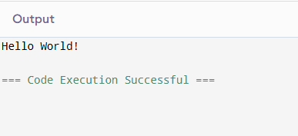

**2.** Java Program to take input from the user and print the sum of two numbers.

Ans.) import java.util.Scanner;

public class Main {

public static void main(String[] args) {

Scanner scanner=new Scanner(System.in);

System.out.println("Enter two numbers");

int a=scanner.nextInt();

int b=scanner.nextInt();

int sum=a+b;

System.out.println("Sum is: " + sum);

}

}

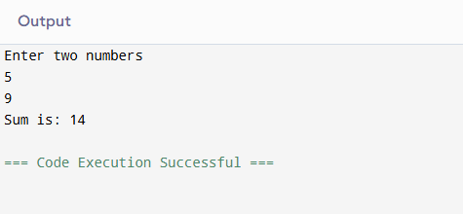

**3.** Create a java program to check whether a number entered by the user is even or odd.

Ans.) import java.util.Scanner;

public class Main {

public static void main(String[] args) {

Scanner scanner=new Scanner(System.in);

System.out.println("Enter a number");

int a=scanner.nextInt();

if(a%2==0)

System.out.println(a+" is even");

else

System.out.println(a+" is odd");

}

}

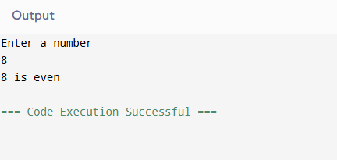

**4.** Create a java program to print the average and sum of 5 numbers entered by the user.

Ans.) import java.util.Scanner;

public class Main {

public static void main(String[] args) {

Scanner scanner=new Scanner(System.in);

System.out.println("Enter 5 numbers");

int a=scanner.nextInt();

int b=scanner.nextInt();

int c=scanner.nextInt();

int d=scanner.nextInt();

int e=scanner.nextInt();

int sum=a+b+c+d+e;

int average=sum/5;

System.out.println("Sum is: "+sum);

System.out.println("Average is: "+average);

}

}

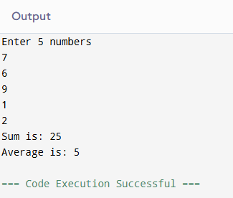

5. Program to calculate the factorial of a number.

Ans.) import java.util.Scanner;

public class Main {

public static void main(String[] args) {

Scanner scanner=new Scanner(System.in);

int factorial=1;

System.out.println("Enter a number");

int a=scanner.nextInt();

for(int i=a;i>=1;i--)

{

factorial=factorial*i;

}

System.out.println("Factorial is: "+factorial);

}

}

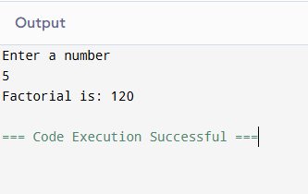

6. Program to print Fibonacci series up to n terms.

Ans.) import java.util.Scanner;

public class Main {

public static void main(String[] args) {

int a=0,b=1,c;

Scanner scanner=new Scanner(System.in);

System.out.println("Enter a number");

int n=scanner.nextInt();

System.out.print(a);

System.out.print(b);

for(int i=3;i<=n;i++)

{

c=a+b;

System.out.print(c);

a=b;

b=c;

}

}

}

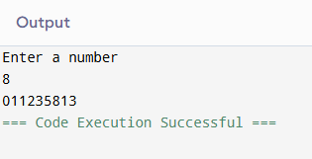

7. Program to reverse a number.

Ans.) import java.util.Scanner;

public class ReverseNumber {

public static void main(String[] args) {

Scanner scanner = new Scanner(System.in);

System.out.print("Enter a number: ");

int number = scanner.nextInt();

int reversed = 0;

while (number != 0) {

int digit = number % 10;

reversed = reversed * 10 + digit;

number /= 10;

}

System.out.println("Reversed Number: " + reversed);

}

}

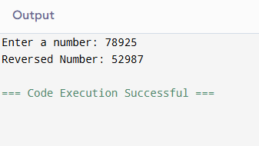

8.) Program to check if a number is palindrome.

Ans.) import java.util.Scanner;

public class PalindromeCheck {

public static void main(String[] args) {

Scanner scanner = new Scanner(System.in);

System.out.print("Enter a number: ");

int number = scanner.nextInt();

int original = number;

int reversed = 0;

while (number != 0) {

int digit = number % 10;

reversed = reversed * 10 + digit;

number /= 10;

}

if (original == reversed) {

System.out.println("The number is a palindrome.");

} else {

System.out.println("The number is not a palindrome.");

}

}

}

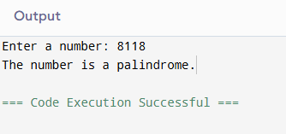

9.) Program for a simple calculator.

Ans.) import java.util.Scanner;

public class SimpleCalculator {

public static void main(String[] args) {

Scanner scanner = new Scanner(System.in);

System.out.println("Enter first number: ");

double num1 = scanner.nextDouble();

System.out.println("Enter an operator (+, -, *, /): ");

char operator = scanner.next().charAt(0);

System.out.println("Enter second number: ");

double num2 = scanner.nextDouble();

double result;

switch (operator) {

case '+':

result = num1 + num2;

break;

case '-':

result = num1 - num2;

break;

case '*':

result = num1 * num2;

break;

case '/':

if (num2 != 0) {

result = num1 / num2;

} else {

System.out.println("Division by zero is not allowed.");

scanner.close();

return;

}

break;

default:

System.out.println("Invalid operator.");

scanner.close();

return;

}

System.out.println("The result is: " + result);

}

}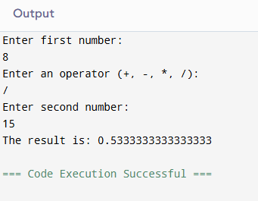

10.) Program to check if a number is prime.

Ans.) import java.util.Scanner;

public class PrimeCheck {

public static void main(String[] args) {

Scanner scanner = new Scanner(System.in);

System.out.print("Enter a number: ");

int number = scanner.nextInt();

boolean isPrime = true;

if (number <= 1) {

isPrime = false;

} else {

for (int i = 2; i <= Math.sqrt(number); i++) {

if (number % i == 0) {

isPrime = false;

break;

}

}

}

if (isPrime) {

System.out.println("The number is prime.");

} else {

System.out.println("The number is not prime.");

}

}

}

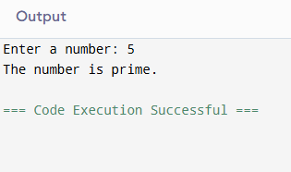

11.) Program to check if a number is an armstrong number.

Ans.) import java.util.Scanner;

public class ArmstrongNumber {

public static void main(String[] args) {

Scanner scanner = new Scanner(System.in);

System.out.print("Enter a number: ");

int number = scanner.nextInt();

int original = number;

int sum = 0;

while (number != 0) {

int digit = number % 10;

sum += Math.pow(digit, 3);

number /= 10;

}

if (sum == original) {

System.out.println("The number is an Armstrong number.");

} else {

System.out.println("The number is not an Armstrong number.");

}

}

}

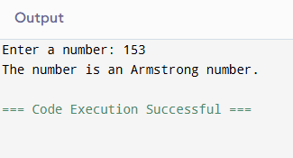

12.) Program to find the largest of two numbers using ternary operators.

Ans.) import java.util.Scanner;

public class LargestOfTwo {

public static void main(String[] args) {

Scanner scanner = new Scanner(System.in);

System.out.print("Enter the first number: ");

int num1 = scanner.nextInt();

System.out.print("Enter the second number: ");

int num2 = scanner.nextInt();

int largest = (num1 > num2) ? num1 : num2;

System.out.println("The largest number is: " + largest);

}

}

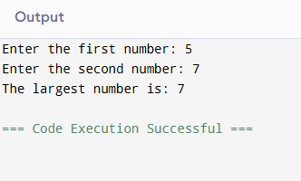

13.) Program to print multiplication table.

Ans.) import java.util.Scanner;

public class MultiplicationTable {

public static void main(String[] args) {

Scanner scanner = new Scanner(System.in);

System.out.print("Enter a number: ");

int number = scanner.nextInt();

for (int i = 1; i <= 10; i++) {

System.out.println(number + " x " + i + " = " + (number * i));

}

}

}

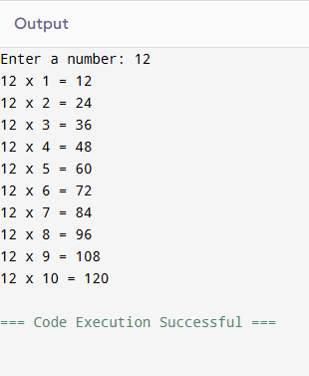

14.) Program to calculate sum and average of array elements.

Ans.) import java.util.Scanner;

public class SumAndAverage {

public static void main(String[] args) {

Scanner scanner = new Scanner(System.in);

System.out.print("Enter the number of elements in the array: ");

int n = scanner.nextInt();

int[] array = new int[n];

System.out.println("Enter the elements of the array:");

for (int i = 0; i < n; i++) {

array[i] = scanner.nextInt();

}

int sum = 0;

for (int i = 0; i < n; i++) {

sum += array[i];

}

double average = (double) sum / n;

System.out.println("Sum of array elements: " + sum);

System.out.println("Average of array elements: " + average);

}

}

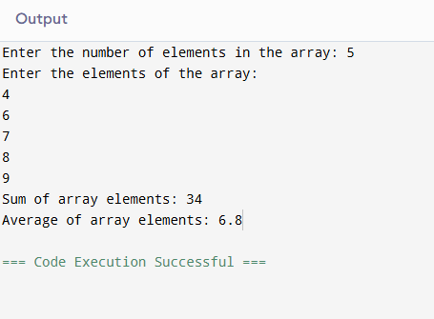

15.) Program to reverse a string.

Ans.) import java.util.Scanner;

public class ReverseString {

public static void main(String[] args) {

Scanner scanner = new Scanner(System.in);

System.out.print("Enter a string: ");

String input = scanner.nextLine();

String reversed = "";

for (int i = input.length() - 1; i >= 0; i--) {

reversed += input.charAt(i);

}

System.out.println("Reversed String: " + reversed);

}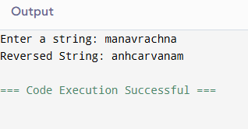

}

16.) Program to find factorial of a number using recursion.

Ans.) import java.util.Scanner;

public class FactorialRecursion {

public static void main(String[] args) {

Scanner scanner = new Scanner(System.in);

System.out.print("Enter a number: ");

int number = scanner.nextInt();

long factorial = findFactorial(number);

System.out.println("Factorial of " + number + " is: " + factorial);

}

public static long findFactorial(int n) {

if (n == 0 || n == 1) {

return 1;

}

return n * findFactorial(n - 1);

}

}

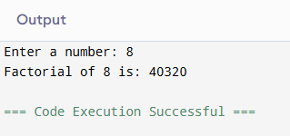

17.) Program to sort an array in ascending order.

Ans.) import java.util.Scanner;

import java.util.Arrays;

public class SortArray {

public static void main(String[] args) {

Scanner scanner = new Scanner(System.in);

System.out.print("Enter the number of elements in the array: ");

int n = scanner.nextInt();

int[] array = new int[n];

System.out.println("Enter the elements of the array:");

for (int i = 0; i < n; i++) {

array[i] = scanner.nextInt();

}

Arrays.sort(array);

System.out.println("Array in ascending order:");

for (int num : array) {

System.out.print(num + " ");

}

}

}

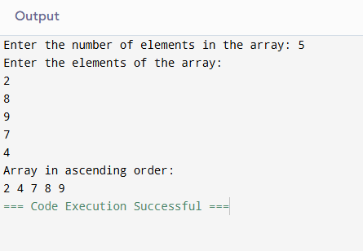

18.) Program to check palindrome for a string.

Ans.) import java.util.Scanner;

public class PalindromeString {

public static void main(String[] args) {

Scanner scanner = new Scanner(System.in);

System.out.print("Enter a string: ");

String input = scanner.nextLine();

String reversed = new StringBuilder(input).reverse().toString();

if (input.equalsIgnoreCase(reversed)) {

System.out.println("The string is a palindrome.");

} else {

System.out.println("The string is not a palindrome.");

}

}

}

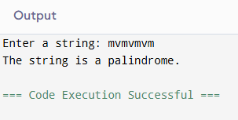

19.) Program to count vowels and consonants in a string.

Ans.) import java.util.Scanner;

public class VowelConsonantCount {

public static void main(String[] args) {

Scanner scanner = new Scanner(System.in);

System.out.print("Enter a string: ");

String input = scanner.nextLine().toLowerCase();

int vowelCount = 0;

int consonantCount = 0;

for (char c : input.toCharArray()) {

if (c >= 'a' && c <= 'z') {

if (c == 'a' || c == 'e' || c == 'i' || c == 'o' || c == 'u') {

vowelCount++;

} else {

consonantCount++;

}

}

}

System.out.println("Number of vowels: " + vowelCount);

System.out.println("Number of consonants: " + consonantCount);

}

}

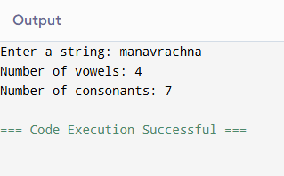

20.) Program to implement a simple banking system.

Ans.) import java.util.Scanner;

public class SimpleBankingSystem {

public static void main(String[] args) {

Scanner scanner = new Scanner(System.in);

double balance = 0.0;

while (true) {

System.out.println("\n--- Banking System ---");

System.out.println("1. Deposit");

System.out.println("2. Withdraw");

System.out.println("3. Check Balance");

System.out.println("4. Exit");

System.out.print("Choose an option: ");

int choice = scanner.nextInt();

switch (choice) {

case 1:

System.out.print("Enter the amount to deposit: ");

double depositAmount = scanner.nextDouble();

if (depositAmount > 0) {

balance += depositAmount;

System.out.println("Amount deposited successfully. Current balance: " + balance);

} else {

System.out.println("Invalid deposit amount.");

}

break;

case 2:

System.out.print("Enter the amount to withdraw: ");

double withdrawalAmount = scanner.nextDouble();

if (withdrawalAmount > 0 && withdrawalAmount <= balance) {

balance -= withdrawalAmount;

System.out.println("Amount withdrawn successfully. Current balance: " + balance);

} else if (withdrawalAmount > balance) {

System.out.println("Insufficient balance.");

} else {

System.out.println("Invalid withdrawal amount.");

}

break;

case 3:

System.out.println("Your current balance is: " + balance);

break;

case 4:

System.out.println("Thank you!");

scanner.close();

return;

default:

System.out.println("Invalid option. Please choose again.");

}

}

}

}

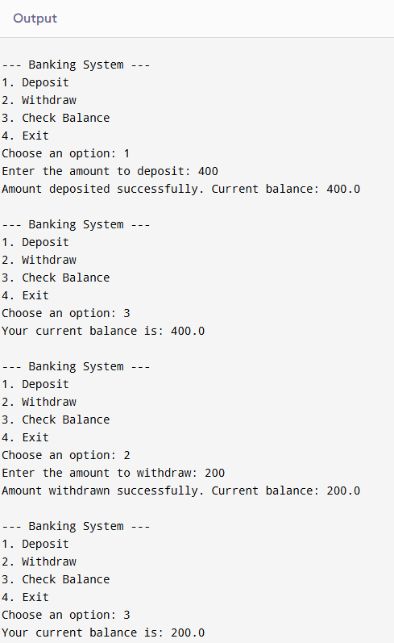

21.) Program to demonstrate type casting.

Ans.) public class TypeCastingDemo {

public static void main(String[] args) {

int intValue = 42;

double doubleValue = intValue;

System.out.println("Implicit Type Casting (int to double): " + doubleValue);

double originalDouble = 42.99;

int narrowedInt = (int) originalDouble;

System.out.println("Explicit Type Casting (double to int): " + narrowedInt);

int num1 = 10;

int num2 = 3;

double result = (double) num1 / num2;

System.out.println("Type Casting in Expressions (int to double): " + result);

}

}

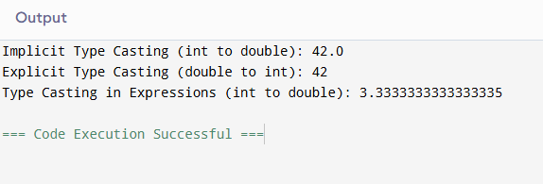

22.) Program to generate prime numbers between 1 and a given number.

Ans.) import java.util.Scanner;

public class PrimeNumbers {

public static void main(String[] args) {

Scanner scanner = new Scanner(System.in);

System.out.print("Enter a number: ");

int limit = scanner.nextInt();

System.out.println("Prime numbers between 1 and " + limit + ":");

for (int i = 2; i <= limit; i++) {

if (isPrime(i)) {

System.out.print(i + " ");

}

}

}

private static boolean isPrime(int number) {

if (number <= 1) {

return false;

}

for (int i = 2; i <= Math.sqrt(number); i++) {

if (number % i == 0) {

return false;

}

}

return true;

}

}

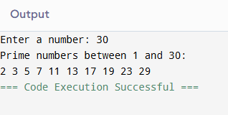

23.) Program to demonstrate a simple class with methods.

Ans.) public class newclass {

public int add(int num1, int num2) {

return num1 + num2;

}

public void exit() {

System.out.println("Exit");

}

public static void main(String[] args) {

newclass newclass = new newclass();

int sum = newclass.add(10, 20);

System.out.println("The sum of 10 and 20 is: " + sum);

newclass.exit();

}

}

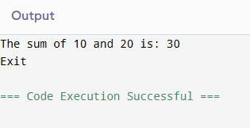

24.) Program for a class with parameterized constructor.

Ans.) public class ParameterizedConstructor {

String name;

int age;

public ParameterizedConstructor(String name, int age) {

this.name = name;

this.age = age;

}

public void displayInfo() {

System.out.println("Name: " + name);

System.out.println("Age: " + age);

}

public static void main(String[] args) {

ParameterizedConstructor person = new ParameterizedConstructor("Chandler", 25);

person.displayInfo();

}

}

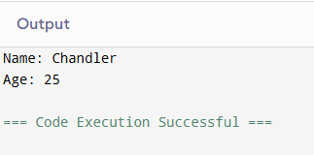

25.) Program to find area of rectangle using methods.

Ans.) import java.util.Scanner;

public class RectangleArea {

public double calculateArea(double length, double width) {

return length * width;

}

public static void main(String[] args) {

Scanner scanner = new Scanner(System.in);

System.out.print("Enter the length of the rectangle: ");

double length = scanner.nextDouble();

System.out.print("Enter the width of the rectangle: ");

double width = scanner.nextDouble();

RectangleArea rectangle = new RectangleArea();

double area = rectangle.calculateArea(length, width);

System.out.println("Area of the rectangle: " + area);

}

}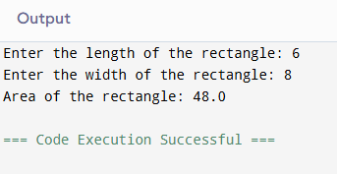

26.) Program for Bank account class with deposit and withdraw methods.

Ans.) public class BankAccount {

private double balance;

public BankAccount(double initialBalance) {

this.balance = initialBalance;

}

public void deposit(double amount) {

if (amount > 0) {

balance += amount;

System.out.println("Successfully deposited: " + amount);

} else {

System.out.println("Invalid deposit amount.");

}

}

public void withdraw(double amount) {

if (amount > 0 && amount <= balance) {

balance -= amount;

System.out.println("Successfully withdrawn: " + amount);

} else if (amount > balance) {

System.out.println("Insufficient balance.");

} else {

System.out.println("Invalid withdrawal amount.");

}

}

public double getBalance() {

return balance;

}

public static void main(String[] args) {

BankAccount account = new BankAccount(1000.0);

account.deposit(500.0);

System.out.println("Current balance: " + account.getBalance());

account.withdraw(300.0);

System.out.println("Current balance: " + account.getBalance());

account.withdraw(1500.0);

System.out.println("Current balance: " + account.getBalance());

}

}

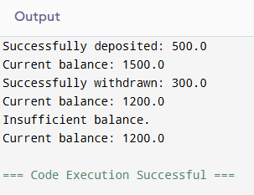

27.) Program to demonstrate method overloading.

Ans.) public class MethodOverloading {

public void display(int number) {

System.out.println("Integer: " + number);

}

public void display(String text) {

System.out.println("String: " + text);

}

public void display(double value) {

System.out.println("Double: " + value);

}

public static void main(String[] args) {

MethodOverloading example = new MethodOverloading();

example.display(25);

example.display("Hello, World!");

example.display(12.34);

}

}

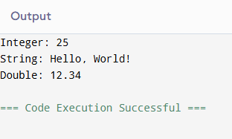

28.) Program to demonstrate static methods.

Ans.) public class StaticMethod{

public static int addNumbers(int a, int b) {

return a + b;

}

public static void displayMessage() {

System.out.println("Static method called");

}

public static void main(String[] args) {

int sum = StaticMethod.addNumbers(10, 20);

System.out.println("Sum of 10 and 20 is: " + sum);

StaticMethod.displayMessage();

}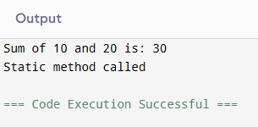

}

29.) Program to demonstrate method overriding.

Ans.) class Animal {

public void move() {

System.out.println("Animal is moving.");

}

public void eat() {

System.out.println("Animal is eating.");

}

}

class Dog extends Animal {

@Override

public void move() {

System.out.println("Dog is running.");

}

public void bark() {

System.out.println("Dog is barking.");

}

}

public class Main {

public static void main(String[] args) {

Dog d = new Dog();

d.move();

d.eat();

d.bark();

}

}

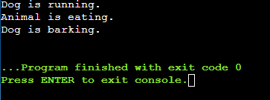

30.) Program to demonstrate getters and setters.

Ans.) public class Person {

private String name;

private int age;

public String getName() {

return name;

}

public void setName(String name) {

this.name = name;

}

public int getAge() {

return age;

}

public void setAge(int age) {

if (age > 0) {

this.age = age;

} else {

System.out.println("Age must be a positive number.");

}

}

public static void main(String[] args) {

Person person = new Person();

person.setName("Chandler");

person.setAge(25);

System.out.println("Name: " + person.getName());

System.out.println("Age: " + person.getAge());

}

}

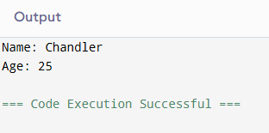

31.) Program to demonstrate class with multiple methods.

Ans.) public class Person {

private String name;

private int age;

public String getName() {

return name;

}

public void setName(String name) {

this.name = name;

}

public int getAge() {

return age;

}

public void setAge(int age) {

if (age > 0) {

this.age = age;

} else {

System.out.println("Age must be a positive number.");

}

}

public static void main(String[] args) {

Person person = new Person();

person.setName("Chandler");

person.setAge(25);

System.out.println("Name: " + person.getName());

System.out.println("Age: " + person.getAge());

}

}

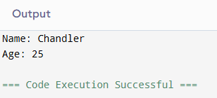

32.) Program to demonstrate object passing in methods.

Ans.) class Rectangle {

private double length;

private double width;

public Rectangle(double length, double width) {

this.length = length;

this.width = width;

}

public double calculateArea() {

return length * width;

}

public void displayDimensions() {

System.out.println("Length: " + length + ", Width: " + width);

}

}

public class ObjectPassing {

public void printRectangleDetails(Rectangle rectangle) {

rectangle.displayDimensions();

System.out.println("Area: " + rectangle.calculateArea());

}

public static void main(String[] args) {

Rectangle rect = new Rectangle(10.5, 5.0);

ObjectPassing objPass = new ObjectPassing();

objPass.printRectangleDetails(rect);

}

}

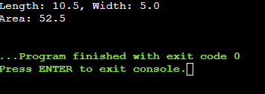

33.) Program to create a simple class to find out the area and perimeter of rectangle using super and this keyword.

Ans.) class Shape {

protected double length;

protected double width;

public Shape(double length, double width) {

this.length = length;

this.width = width;

}

public void displayDimensions() {

System.out.println("Length: " + this.length + ", Width: " + this.width);

}

}

class Rectangle extends Shape {

public Rectangle(double length, double width) {

super(length, width); // Calls the constructor of the parent class

}

public double calculateArea() {

return this.length * this.width; // Refers to the current object's variables

}

public double calculatePerimeter() {

return 2 * (this.length + this.width); // Refers to the current object's variables

}

public void displayDetails() {

super.displayDimensions(); // Calls the method from the parent class

System.out.println("Area: " + calculateArea());

System.out.println("Perimeter: " + calculatePerimeter());

}

}

public class Main {

public static void main(String[] args) {

Rectangle rectangle = new Rectangle(10.5, 5.0);

rectangle.displayDetails();

}

}

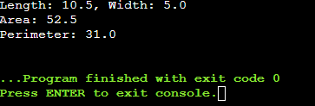

34.) Program to count the number of objects created for class using static member functions.

Ans.) public class ObjectCounter {

private static int count = 0;

public ObjectCounter() {

count++;

}

public static int getObjectCount() {

return count;

}

public static void main(String[] args) {

ObjectCounter obj1 = new ObjectCounter();

ObjectCounter obj2 = new ObjectCounter();

ObjectCounter obj3 = new ObjectCounter();

System.out.println("Number of objects created: " + ObjectCounter.getObjectCount());

}

}

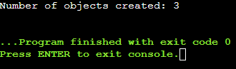

35.) Program to design a class using abstract methods and abstract classes.

Ans.) abstract class Shape {

public abstract double calculateArea();

public abstract double calculatePerimeter();

public void displayDetails() {

System.out.println("This is a shape.");

}

}

class Rectangle extends Shape {

private double length;

private double width;

public Rectangle(double length, double width) {

this.length = length;

this.width = width;

}

@Override

public double calculateArea() {

return length * width;

}

@Override

public double calculatePerimeter() {

return 2 * (length + width);

}

@Override

public void displayDetails() {

System.out.println("Rectangle:");

System.out.println("Length: " + length + ", Width: " + width);

System.out.println("Area: " + calculateArea());

System.out.println("Perimeter: " + calculatePerimeter());

}

}

public class Main {

public static void main(String[] args) {

Rectangle rectangle = new Rectangle(10.5, 5.0);

rectangle.displayDetails();

}

}

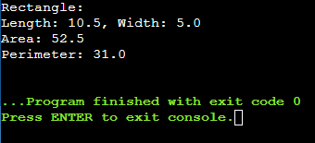

36.) Program to demonstrate the use of multilevel inheritance.

Ans.) class Animal {

public void eat() {

System.out.println("This animal eats food.");

}

}

class Mammal extends Animal {

public void walk() {

System.out.println("This mammal walks on land.");

}

}

class Dog extends Mammal {

public void bark() {

System.out.println("The dog barks.");

}

}

public class MultilevelInheritance {

public static void main(String[] args) {

Dog dog = new Dog();

dog.eat();

dog.walk();

dog.bark();

}

}

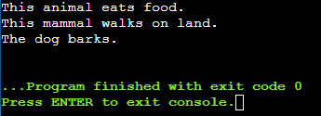

37.) Program to demonstrate the use of multiple inheritance.

Ans.) interface Animal {

void eat();

}

interface Bird {

void fly();

}

class Bat implements Animal, Bird {

@Override

public void eat() {

System.out.println("Bat eats insects.");

}

@Override

public void fly() {

System.out.println("Bat flies in the night.");

}

}

public class MultipleInheritance{

public static void main(String[] args) {

Bat bat = new Bat();

bat.eat();

bat.fly();

}

}

